# COMPLETE EXAMPLE HIERARCHICAL

# MULTIPLE LINEAR REGRESSION

**Research Question:** After **controlling** for demographic variables, does the extroversion of the participant predict how well they take care of their car?

**Data set:** data 2.csv

**IV(s):**

* Sex – gender of the participant (0 = female, 1 = male)
* Age – age of the participant
* Extro – extroversion of the participant, low numbers are introverted, high numbers are extroverted.

**DV:**

* Car – how well a person takes care of their car (regular washes, cleaned, oil changed, etc.).

**Power:**

1. Open Gpower!
   1. Test family: F-test
   2. Statistical Test: Linear multiple regression: fixed model, R2 increase
      1. We are using multiple regression because we have more than one predictor.
      2. R2 increase indicates that we are asking if the addition of more predictors to previous model are useful.
   3. Estimate an effect size: click determine 🡪 use R square sizes you think might be accurate, remember small, medium, and large estimates from the notes.
      1. You will be entering partial R2 🡪 what do you think the effect size is for the last step of the model?
   4. Alpha = .05
   5. Power (1-beta .20) = .80
   6. Number of tested predictors: number of IVs/X variables in that step.
   7. Total number of predictors: number of IVs/Xs overall.
2. Let’s estimate the following:
   1. Medium effect size (*R2* = .09)
   2. Number of tested predictors: 1 (extroversion)
   3. Total number of predictors: 3 (extroversion + gender + age)

Says we needed to run 82 people to find a significant effect with a medium effect size.

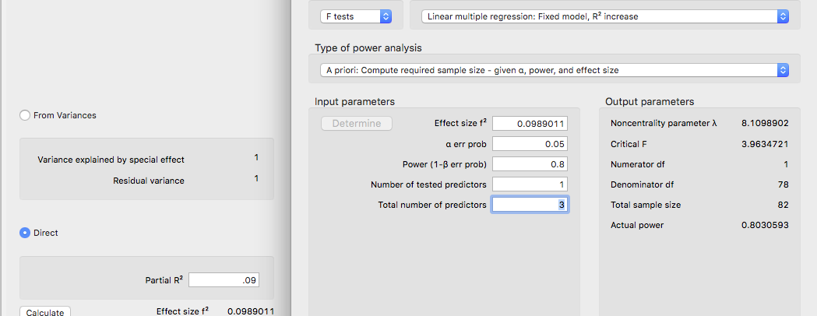

**Results**

Age, gender, and extroversion were used to predict a person’s overall care for their car. The data were screened for assumptions, and no participants were eliminated due to outliers for high *z*-scores. Linearity, normality, multicollinearity, homogeneity, and homoscedasticity were all met.

Age and gender were entered first into a hierarchical regression to control for demographic differences in care maintenance. Overall, this model was significant, indicating that demographics predict how much a person takes care of their car, *F*(2, 37) = 19.25, *p* < .001, *R²* = .51. Gender was a strong predictor of car maintenance, *b* = 27.74, *t*(37) = 5.86, *p* < .001, *pr2* = .48, which showed that males are more likely to take care of their cars by regular maintenance. Age was also positively related to car maintenance, *b* = 0.49, *t*(37) = 2.34, *p* = .03, *pr2* = .13; therefore, older participants indicated better car care. Next, extroversion was added in a second step to examine its predictive value after controlling for demographic variables. The addition of this variable was significant, *F*(3, 36) = 21.18, *p* <.001, *R2 =* .64, Δ*R2*= .13. Participants who were more extroverted took better care of their cars, *b* = 0.46, *t*(36) = 3.57, *p* = .001, *pr2* = .26. See Figure 1 for a depiction of the overall relationship.

DATA SCREENING ONLY

## Linear Regression

| **Model Summary** | | | | | | | | | |
| --- | --- | --- | --- | --- | --- | --- | --- | --- | --- |
| **Model** | | **R** | | **R²** | | **Adjusted R²** | | **RMSE** | |
| 1 |  | 0.799 |  | 0.638 |  | 0.608 |  | 13.012 |  |
|  | | | | | | | | | |

| **ANOVA** | | | | | | | | | | | | | |
| --- | --- | --- | --- | --- | --- | --- | --- | --- | --- | --- | --- | --- | --- |
| **Model** | |  | | **Sum of Squares** | | **df** | | **Mean Square** | | **F** | | **p** | |
| 1 |  | Regression |  | 10755 |  | 3 |  | 3585.1 |  | 21.18 |  | < .001 |  |
|  |  | Residual |  | 6095 |  | 36 |  | 169.3 |  |  |  |  |  |
|  |  | Total |  | 16850 |  | 39 |  |  |  |  |  |  |  |
|  | | | | | | | | | | | | | |

| **Coefficients** | | | | | | | | | | | | | |
| --- | --- | --- | --- | --- | --- | --- | --- | --- | --- | --- | --- | --- | --- |
| **Model** | |  | | **Unstandardized** | | **Standard Error** | | **Standardized** | | **t** | | **p** | |
| 1 |  | intercept |  | 11.426 |  | 7.308 |  |  |  | 1.563 |  | 0.127 |  |
|  |  | extro |  | 0.463 |  | 0.130 |  | 0.441 |  | 3.574 |  | 0.001 |  |
|  |  | sex |  | 20.038 |  | 4.650 |  | 0.488 |  | 4.309 |  | < .001 |  |
|  |  | age |  | 0.154 |  | 0.206 |  | 0.085 |  | 0.749 |  | 0.459 |  |
|  | | | | | | | | | | | | | |

| **Casewise Diagnostics** | | | | | | | | | |
| --- | --- | --- | --- | --- | --- | --- | --- | --- | --- |
| **Case Number** | | **Std. Residual** | | **car** | | **Predicted Value** | | **Residual** | |
| 1 |  | -1.049 |  | 46.000 |  | 58.486 |  | -12.486 |  |
| 2 |  | 1.593 |  | 79.000 |  | 58.950 |  | 20.050 |  |
| 3 |  | -0.937 |  | 33.000 |  | 44.317 |  | -11.317 |  |
| 4 |  | -0.099 |  | 63.000 |  | 64.203 |  | -1.203 |  |
| 5 |  | -0.747 |  | 20.000 |  | 29.185 |  | -9.185 |  |
| 6 |  | -0.896 |  | 18.000 |  | 29.338 |  | -11.338 |  |
| 7 |  | -0.363 |  | 11.000 |  | 15.439 |  | -4.439 |  |
| 8 |  | 1.992 |  | 97.000 |  | 74.396 |  | 22.604 |  |
| 9 |  | -0.010 |  | 63.000 |  | 63.120 |  | -0.120 |  |
| 10 |  | 1.201 |  | 46.000 |  | 30.883 |  | 15.117 |  |
| 11 |  | -1.406 |  | 21.000 |  | 38.450 |  | -17.450 |  |
| 12 |  | 0.947 |  | 71.000 |  | 59.105 |  | 11.895 |  |
| 13 |  | -0.630 |  | 59.000 |  | 66.826 |  | -7.826 |  |
| 14 |  | 0.257 |  | 44.000 |  | 40.882 |  | 3.118 |  |
| 15 |  | 0.813 |  | 30.000 |  | 19.917 |  | 10.083 |  |
| 16 |  | 0.161 |  | 80.000 |  | 78.101 |  | 1.899 |  |
| 17 |  | 0.684 |  | 45.000 |  | 36.441 |  | 8.559 |  |
| 18 |  | -1.739 |  | 26.000 |  | 47.097 |  | -21.097 |  |
| 19 |  | -1.123 |  | 33.000 |  | 46.906 |  | -13.906 |  |
| 20 |  | -0.775 |  | 7.000 |  | 16.520 |  | -9.520 |  |
| 21 |  | 1.408 |  | 50.000 |  | 32.579 |  | 17.421 |  |
| 22 |  | 0.594 |  | 54.000 |  | 46.788 |  | 7.212 |  |
| 23 |  | 0.984 |  | 73.000 |  | 60.803 |  | 12.197 |  |
| 24 |  | -0.667 |  | 19.000 |  | 27.174 |  | -8.174 |  |
| 25 |  | 1.009 |  | 36.000 |  | 23.315 |  | 12.685 |  |
| 26 |  | -0.505 |  | 31.000 |  | 37.058 |  | -6.058 |  |
| 27 |  | 1.992 |  | 71.000 |  | 46.288 |  | 24.712 |  |
| 28 |  | -0.424 |  | 15.000 |  | 20.227 |  | -5.227 |  |
| 29 |  | -0.856 |  | 40.000 |  | 50.766 |  | -10.766 |  |
| 30 |  | 0.102 |  | 61.000 |  | 59.722 |  | 1.278 |  |
| 31 |  | -0.227 |  | 45.000 |  | 47.832 |  | -2.832 |  |
| 32 |  | 0.502 |  | 42.000 |  | 35.670 |  | 6.330 |  |
| 33 |  | -0.204 |  | 57.000 |  | 59.568 |  | -2.568 |  |
| 34 |  | -0.101 |  | 34.000 |  | 35.208 |  | -1.208 |  |
| 35 |  | 0.601 |  | 26.000 |  | 18.681 |  | 7.319 |  |
| 36 |  | 1.629 |  | 47.000 |  | 26.713 |  | 20.287 |  |
| 37 |  | -1.154 |  | 42.000 |  | 56.634 |  | -14.634 |  |
| 38 |  | -0.834 |  | 44.000 |  | 54.473 |  | -10.473 |  |
| 39 |  | 0.324 |  | 59.000 |  | 54.936 |  | 4.064 |  |
| 40 |  | -1.994 |  | 27.000 |  | 52.002 |  | -25.002 |  |
|  | | | | | | | | | |

| **Residuals Statistics** | | | | | | | | | | | |
| --- | --- | --- | --- | --- | --- | --- | --- | --- | --- | --- | --- |
|  | | **Minimum** | | **Maximum** | | **Mean** | | **SD** | | **N** | |
| Predicted Value |  | 15.439 |  | 78.101 |  | 44.125 |  | 16.607 |  | 40 |  |
| Residual |  | -25.002 |  | 24.712 |  | 0.000 |  | 12.501 |  | 40 |  |
| Std. Predicted Value |  | -1.727 |  | 2.046 |  | -0.000 |  | 1.000 |  | 40 |  |
| Std. Residual |  | -1.994 |  | 1.992 |  | 0.001 |  | 1.015 |  | 40 |  |
|  | | | | | | | | | | | |

### Residuals vs. Predicted

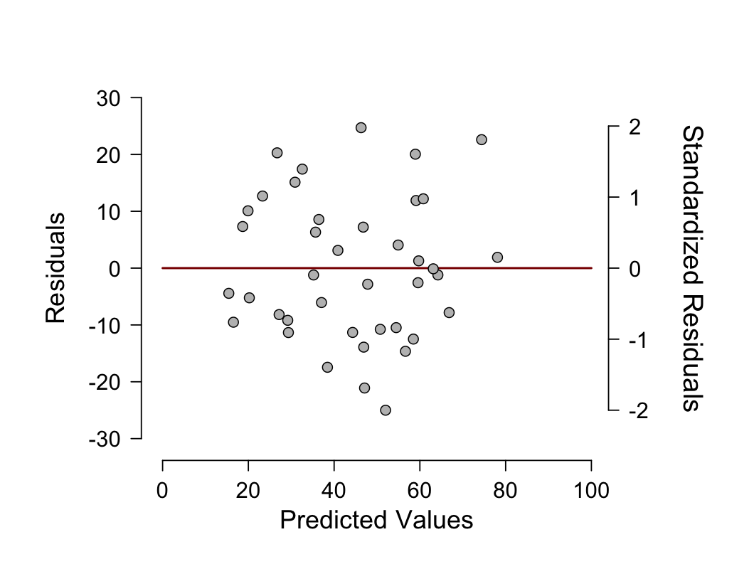

### Standardized Residuals Histogram

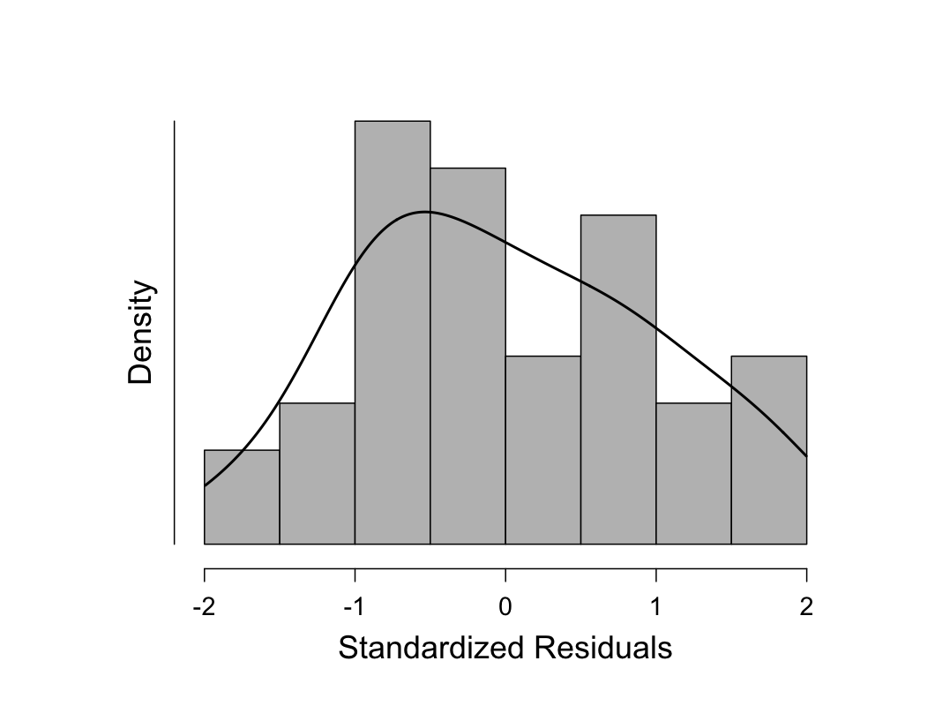

### Q-Q Plot Standardized Residuals

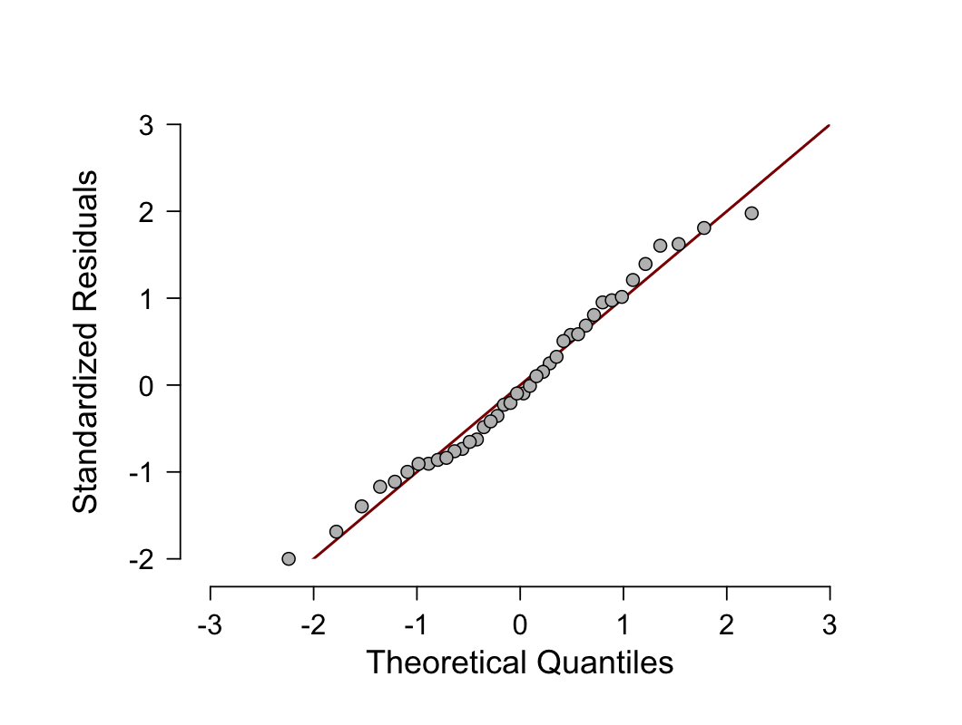

HIERARCHICAL REGRESSION TIME!

STEP 1

## Linear Regression

| **Model Summary** | | | | | | | | | | | | | | | | | | | | | | | |
| --- | --- | --- | --- | --- | --- | --- | --- | --- | --- | --- | --- | --- | --- | --- | --- | --- | --- | --- | --- | --- | --- | --- | --- |
| **Model** | | **R** | | **R²** | | **Adjusted R²** | | **RMSE** | | | | **R² Change** | | **F Change** | | | | **df1** | | **df2** | | **p** | |
| 1 |  | 0.714 |  | 0.510 |  | 0.483 |  | 14.939 | | |  | 0.510 |  | 19.25 | | |  | 2 |  | 37 |  | < .001 |  |
|  | | | | | | | | | | | | | | | | | | | | | | | |
| *F*(2, 37) = 19.25, *p* < .001, *R²* = .51 | | | | | | | | | | | | | | | | | | | | | | | |
| **ANOVA** | | | | | | | | | | | | | | | | | | | | |
| **Model** | |  | | | **Sum of Squares** | | | | **df** | | **Mean Square** | | | | **F** | | **p** | | | |
| 1 |  | Regression | |  | 8593 | | |  | 2 |  | 4296.4 | | |  | 19.25 |  | < .001 | | |  |
|  |  | Residual | |  | 8258 | | |  | 37 |  | 223.2 | | |  |  |  |  | | |  |
|  |  | Total | |  | 16850 | | |  | 39 |  |  | | |  |  |  |  | | |  |
|  | | | | | | | | | | | | | | | | | | | | |

| **Coefficients** | | | | | | | | | | | | | | |
| --- | --- | --- | --- | --- | --- | --- | --- | --- | --- | --- | --- | --- | --- | --- |
| **Model** | |  | | | **Unstandardized** | | **Standard Error** | | **Standardized** | | **t** | | **p** | |
| 1 |  | intercept | |  | 12.563 |  | 8.383 |  |  |  | 1.499 |  | 0.142 |  |
|  |  | sex | |  | 27.741 |  | 4.731 |  | 0.676 |  | 5.864 |  | < .001 |  |
|  |  | age | |  | 0.492 |  | 0.210 |  | 0.270 |  | 2.339 |  | 0.025 |  |
|  |  |  | |  |  |  |  |  |  |  |  |  |  |  |
| Sex, *b* = 27.74, *t*(37) = 5.86, *p* < .001, *pr2* = .48  0 female, 1 male  Age, *b* = 0.49, *t*(37) = 2.34, *p* = .03, *pr2* = .13 | | | | | | | | | | | | | | |
| **Part And Partial Correlations** | | | | | | | |
| **Model** | |  | | **Partial** | | **Part** | |
| 1 |  | sex |  | 0.694 |  | 0.675 |  |
|  |  | age |  | 0.359 |  | 0.269 |  |
|  | | | | | | | |

STEP 2

**Linear Regression**

| **Model Summary** | | | | | | | | | | | | | | | | | | | | | | | |
| --- | --- | --- | --- | --- | --- | --- | --- | --- | --- | --- | --- | --- | --- | --- | --- | --- | --- | --- | --- | --- | --- | --- | --- |
| **Model** | | **R** | | **R²** | | **Adjusted R²** | | **RMSE** | | | | **R² Change** | | **F Change** | | | | **df1** | | **df2** | | **p** | |
| 1 |  | 0.799 |  | 0.638 |  | 0.608 |  | 13.012 | | |  | 0.638 |  | 21.18 | | |  | 3 |  | 36 |  | < .001 |  |
| *F*(3, 36) = 21.18, *p* <.001, *R2 =* .64, Δ*R2*= (.64 - .51) = .13 | | | | | | | | | | | | | | | | | | | | | | | |
| **ANOVA** | | | | | | | | | | | | | | | | | | | | |
| **Model** | |  | | | **Sum of Squares** | | | | **df** | | **Mean Square** | | | | **F** | | **p** | | | |
| 1 |  | Regression | |  | 10755 | | |  | 3 |  | 3585.1 | | |  | 21.18 |  | < .001 | | |  |
|  |  | Residual | |  | 6095 | | |  | 36 |  | 169.3 | | |  |  |  |  | | |  |
|  |  | Total | |  | 16850 | | |  | 39 |  |  | | |  |  |  |  | | |  |
|  | | | | | | | | | | | | | | | | | | | | |

| **Coefficients** | | | | | | | | | | | | | | |
| --- | --- | --- | --- | --- | --- | --- | --- | --- | --- | --- | --- | --- | --- | --- |
| **Model** | |  | | | **Unstandardized** | | **Standard Error** | | **Standardized** | | **t** | | **p** | |
| 1 |  | intercept |  | | 11.426 |  | 7.308 |  |  |  | 1.563 |  | 0.127 |  |
|  |  | sex |  | | 20.038 |  | 4.650 |  | 0.488 |  | 4.309 |  | < .001 |  |
|  |  | age |  | | 0.154 |  | 0.206 |  | 0.085 |  | 0.749 |  | 0.459 |  |
|  |  | extro |  | | 0.463 |  | 0.130 |  | 0.441 |  | 3.574 |  | 0.001 |  |
| Extroversion, *b* = 0.46, *t*(36) = 3.57, *p* = .001, *pr2* = .26 | | | | | | | | | | | | | | |
| **Part And Partial Correlations** | | | | | | | |
| **Model** | |  | | **Partial** | | **Part** | |
| 1 |  | sex |  | 0.583 |  | 0.432 |  |
|  |  | age |  | 0.124 |  | 0.075 |  |
|  |  | extro |  | 0.512 |  | 0.358 |  |
|  | | | | | | | |

| **Casewise Diagnostics** | | | | | | | | | | | | | |
| --- | --- | --- | --- | --- | --- | --- | --- | --- | --- | --- | --- | --- | --- |
| **Case Number** | | **Std. Residual** | | **car** | | **Predicted Value** | | | | **Residual** | | | |
| 1 |  | -1.049 |  | 46.000 |  | 58.486 | | |  | -12.486 | | |  |
| 2 |  | 1.593 |  | 79.000 |  | 58.950 | | |  | 20.050 | | |  |
| 3 |  | -0.937 |  | 33.000 |  | 44.317 | | |  | -11.317 | | |  |
| 4 |  | -0.099 |  | 63.000 |  | 64.203 | | |  | -1.203 | | |  |
| 5 |  | -0.747 |  | 20.000 |  | 29.185 | | |  | -9.185 | | |  |
| 6 |  | -0.896 |  | 18.000 |  | 29.338 | | |  | -11.338 | | |  |
| 7 |  | -0.363 |  | 11.000 |  | 15.439 | | |  | -4.439 | | |  |
| 8 |  | 1.992 |  | 97.000 |  | 74.396 | | |  | 22.604 | | |  |
| 9 |  | -0.010 |  | 63.000 |  | 63.120 | | |  | -0.120 | | |  |
| 10 |  | 1.201 |  | 46.000 |  | 30.883 | | |  | 15.117 | | |  |
| 11 |  | -1.406 |  | 21.000 |  | 38.450 | | |  | -17.450 | | |  |
| 12 |  | 0.947 |  | 71.000 |  | 59.105 | | |  | 11.895 | | |  |
| 13 |  | -0.630 |  | 59.000 |  | 66.826 | | |  | -7.826 | | |  |
| 14 |  | 0.257 |  | 44.000 |  | 40.882 | | |  | 3.118 | | |  |
| 15 |  | 0.813 |  | 30.000 |  | 19.917 | | |  | 10.083 | | |  |
| 16 |  | 0.161 |  | 80.000 |  | 78.101 | | |  | 1.899 | | |  |
| 17 |  | 0.684 |  | 45.000 |  | 36.441 | | |  | 8.559 | | |  |
| 18 |  | -1.739 |  | 26.000 |  | 47.097 | | |  | -21.097 | | |  |
| 19 |  | -1.123 |  | 33.000 |  | 46.906 | | |  | -13.906 | | |  |
| 20 |  | -0.775 |  | 7.000 |  | 16.520 | | |  | -9.520 | | |  |
| 21 |  | 1.408 |  | 50.000 |  | 32.579 | | |  | 17.421 | | |  |
| 22 |  | 0.594 |  | 54.000 |  | 46.788 | | |  | 7.212 | | |  |
| 23 |  | 0.984 |  | 73.000 |  | 60.803 | | |  | 12.197 | | |  |
| 24 |  | -0.667 |  | 19.000 |  | 27.174 | | |  | -8.174 | | |  |
| 25 |  | 1.009 |  | 36.000 |  | 23.315 | | |  | 12.685 | | |  |
| 26 |  | -0.505 |  | 31.000 |  | 37.058 | | |  | -6.058 | | |  |
| 27 |  | 1.992 |  | 71.000 |  | 46.288 | | |  | 24.712 | | |  |
| 28 |  | -0.424 |  | 15.000 |  | 20.227 | | |  | -5.227 | | |  |
| 29 |  | -0.856 |  | 40.000 |  | 50.766 | | |  | -10.766 | | |  |
| 30 |  | 0.102 |  | 61.000 |  | 59.722 | | |  | 1.278 | | |  |
| 31 |  | -0.227 |  | 45.000 |  | 47.832 | | |  | -2.832 | | |  |
| 32 |  | 0.502 |  | 42.000 |  | 35.670 | | |  | 6.330 | | |  |
| 33 |  | -0.204 |  | 57.000 |  | 59.568 | | |  | -2.568 | | |  |
| 34 |  | -0.101 |  | 34.000 |  | 35.208 | | |  | -1.208 | | |  |
| 35 |  | 0.601 |  | 26.000 |  | 18.681 | | |  | 7.319 | | |  |
| 36 |  | 1.629 |  | 47.000 |  | 26.713 | | |  | 20.287 | | |  |
| 37 |  | -1.154 |  | 42.000 |  | 56.634 | | |  | -14.634 | | |  |
| 38 |  | -0.834 |  | 44.000 |  | 54.473 | | |  | -10.473 | | |  |
| 39 |  | 0.324 |  | 59.000 |  | 54.936 | | |  | 4.064 | | |  |
| 40 |  | -1.994 |  | 27.000 |  | 52.002 | | |  | -25.002 | | |  |
|  | | | | | | | | | | | | | |
| **Residuals Statistics** | | | | | | | | | | | | |
|  | | | **Minimum** | | **Maximum** | | **Mean** | | **SD** | | **N** | |
| Predicted Value | |  | 15.439 |  | 78.101 |  | 44.125 |  | 16.607 |  | 40 |  |
| Residual | |  | -25.002 |  | 24.712 |  | 0.000 |  | 12.501 |  | 40 |  |
| Std. Predicted Value | |  | -1.727 |  | 2.046 |  | -0.000 |  | 1.000 |  | 40 |  |
| Std. Residual | |  | -1.994 |  | 1.992 |  | 0.001 |  | 1.015 |  | 40 |  |
|  | | | | | | | | | | | | |